Question:1
Write a C program to print a simple student report card on the screen.
Programming Fundamentals Report Card
Marks obtained = 45
Total Marks = 50
Percentage = 93%
Grade = A.

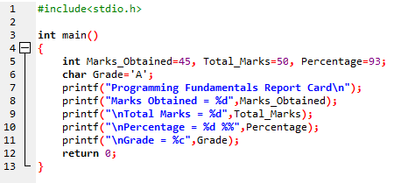
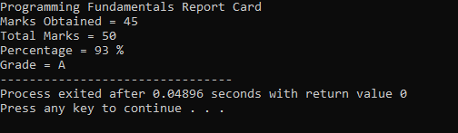

Question:2
Write a C Program to take input from user for a product. It should be Product Name, Price, Quantity, and then display the total cost (Price * Quantity).

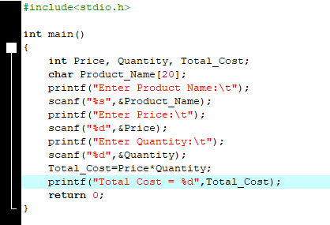
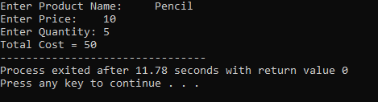

Question:3
Write a C program that asks the user for the radius of a circle and calculates its area and circumference.
(Use: Area = π * r², Circumference = 2 * π * r)

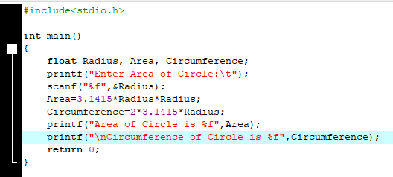
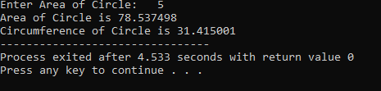

Question:4
Write a C program that takes a user’s daily budget and daily expenditure, then calculates and displays how much they saved or overspent for the day.

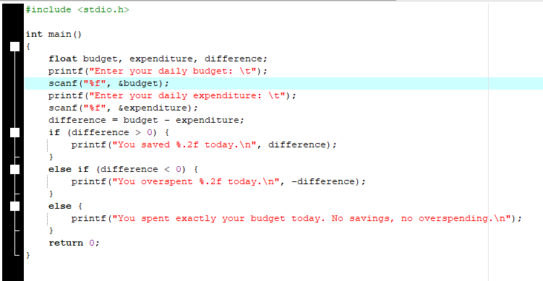
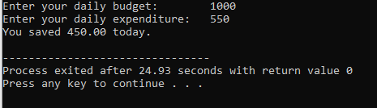
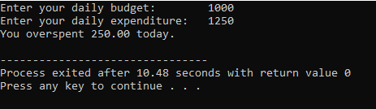
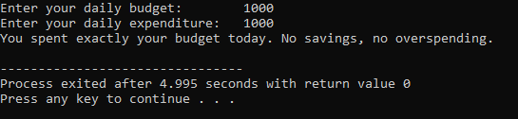

Question:5
Write a C program to convert a user’s height from centimeters to feet and inches.
(Note: 1 foot = 30.48 cm, 1 inch = 2.54 cm)

